**The Ark Documentation.**

**Add new subject: add attachment.**

Once you have seen the confirmation message that the new subject has been created, you can proceed to add an attachment.

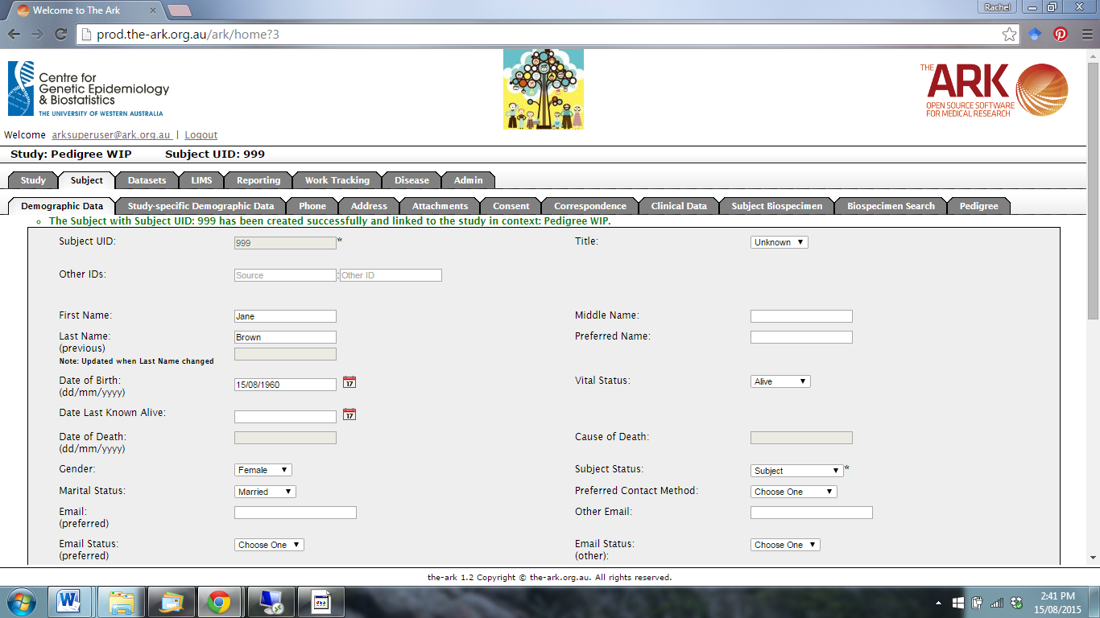

Click on the Attachments function.

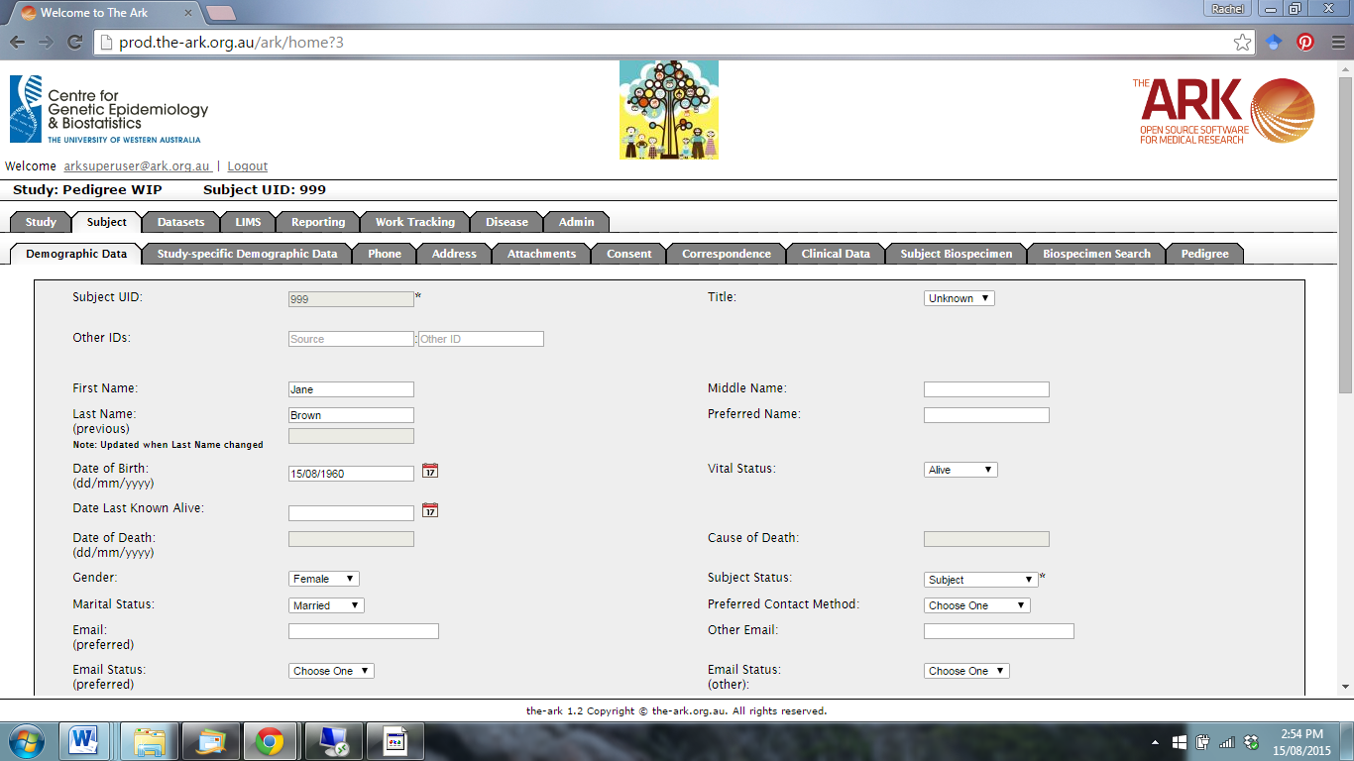

The following page will appear. Click new.

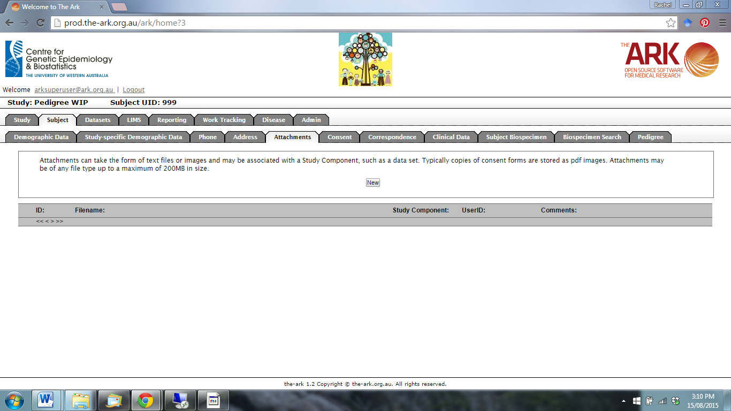

Click on Choose File to navigate to an attachment to upload.

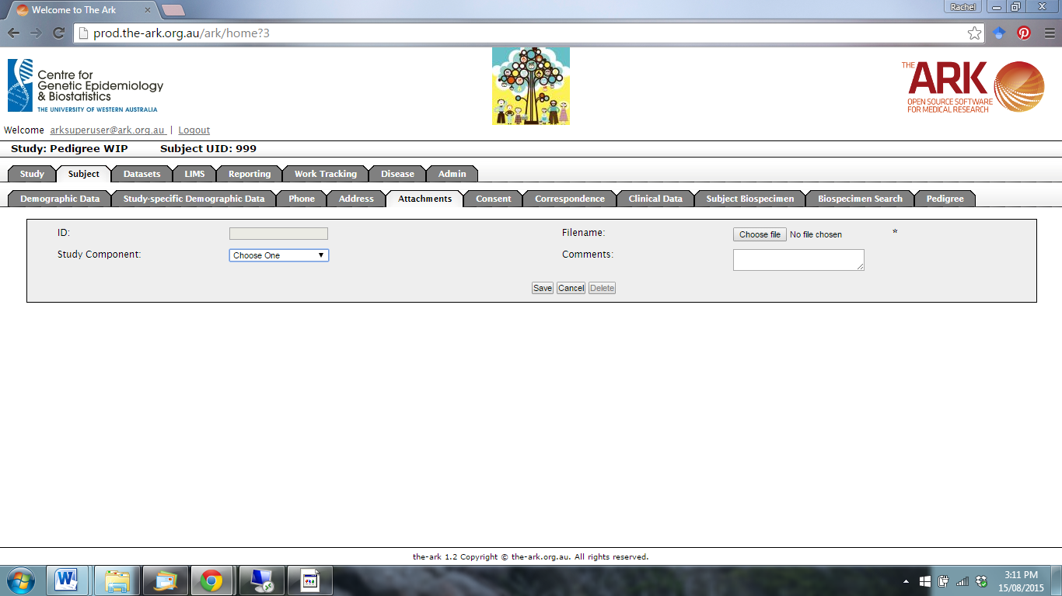

Choose a Study Component from the drop-down menu, or enter comments in the Comment Box. Then click Save.

